**CSA1518-CLOUD COMPUTING**

T. Ashwath

l92011375

**Expt:07**

Create a Virtual Machine with 1 CPU, 2GB RAM and 15GB storage disk using a Type 2 Virtualization Software.

**IMPLEMENTATION:**

STEP 1: DOWNLOAD VMWARE WORKSTATION AND INSTALLED AS TYPE 2 HYPERVISOR

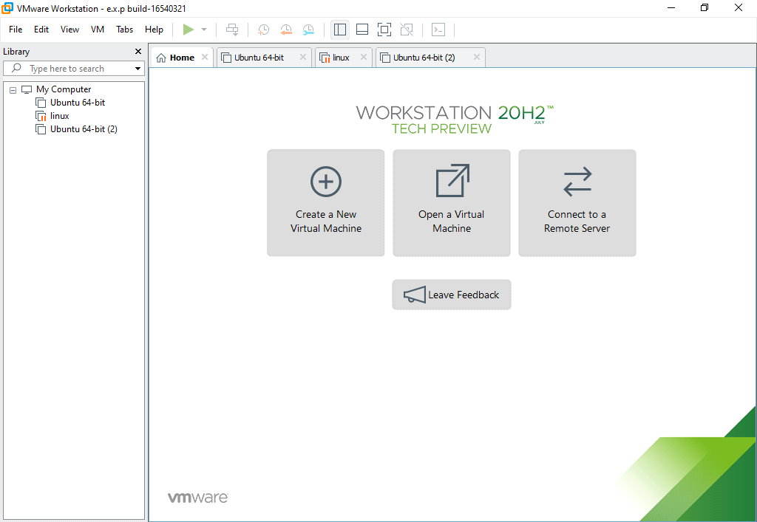

STEP 2: GO TO FILE AND SELECT NEW VIRTUAL MACHINE

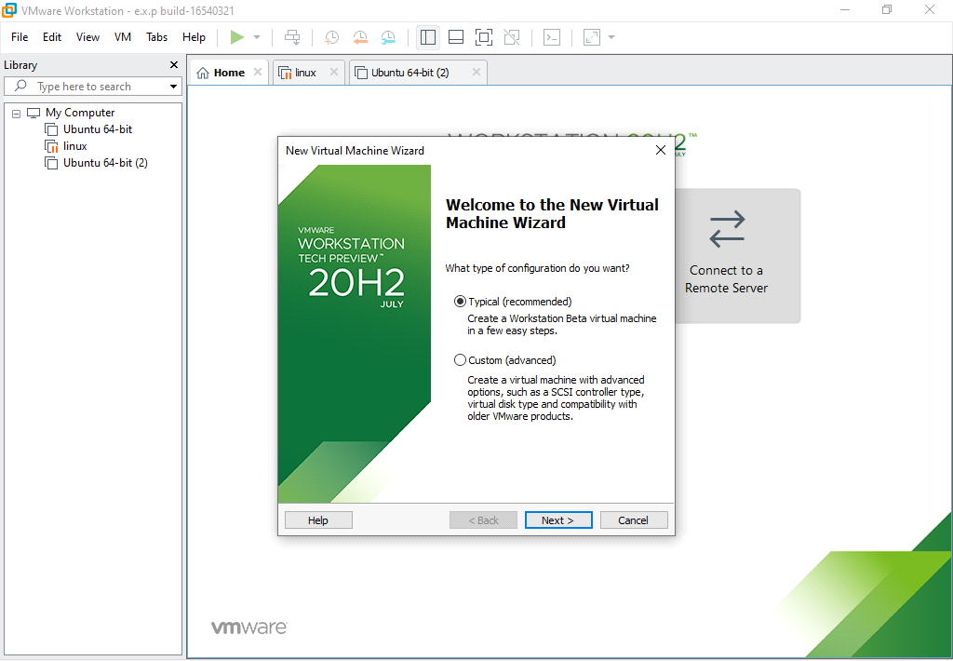

STEP 3:CHOOSE GUEST OPERATING SYSTEM AND VERSION

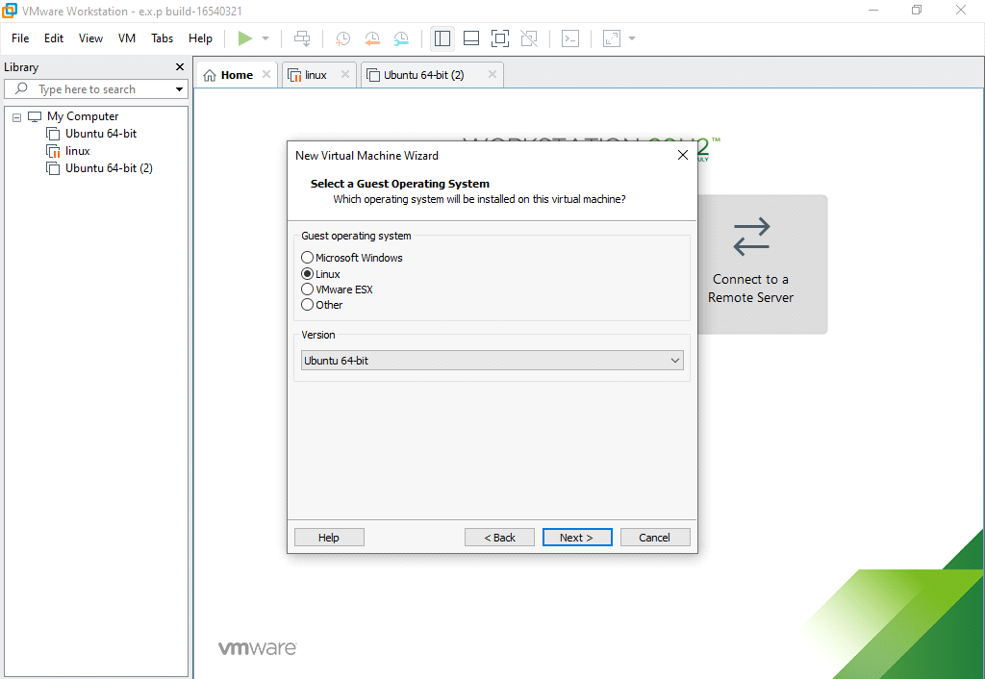

STEP 4: CHOOSE VIRTUAL MACHINE NAME AND LOCATION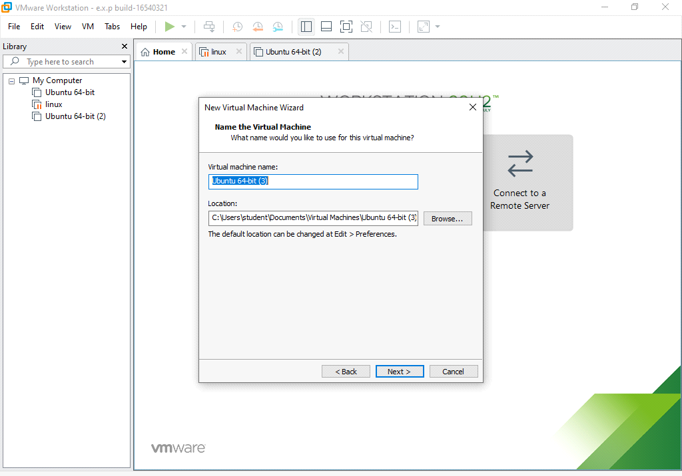STEP 5: MAXIMUM DISK SIZE IS 15 GB AND STORE AS A SINGLE FILE

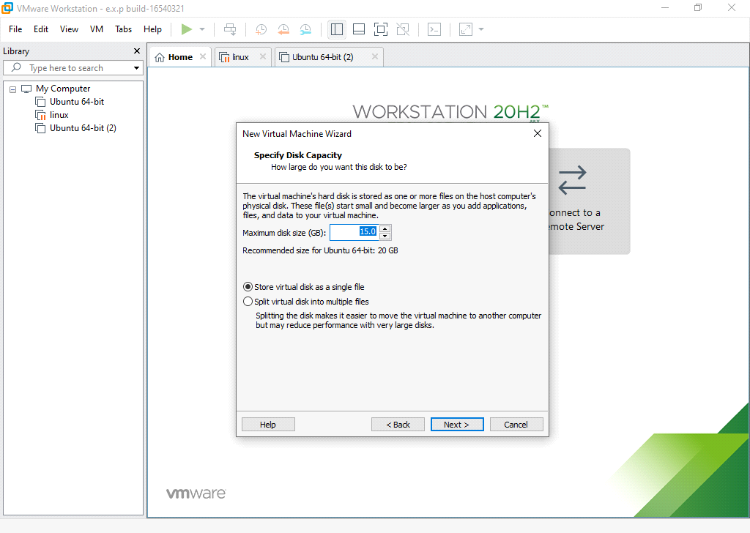

STEP 6: SET HARD DISK SIZE AS 15GB AND MEMORY AS 1GB 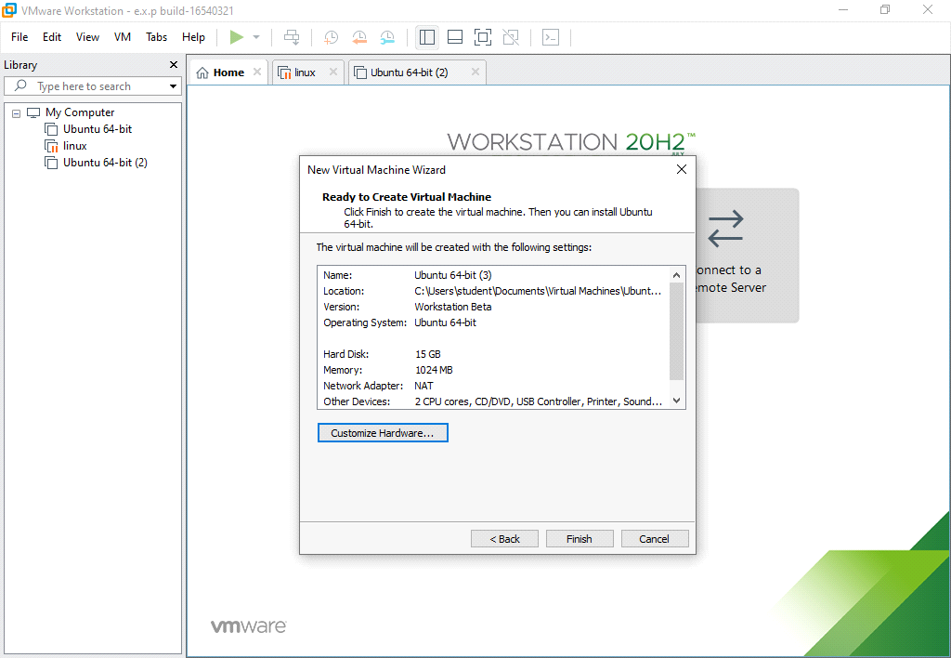

STEP 7:OUTPUT

